Web Designing Assignment

**Module (CSS)**

**1.What are the benefits of using CSS?**

Ans- CSS stands for Cascading Style Sheets. CSS is used to style and layout web pages. Along with HTML. CSS is fundamental to web design.CSS offers several advantages for web development like **Separation of Concerns**, **consistency**, **Faster Loading Times**, **Responsiveness**, **Enhanced Design Options**, **Accessibility**.

**Separation of Concerns**: CSS Separates the content of webpage from its presentation. This makes websites easier to maintain and update.

**Consistency**: CSS ensures a consistent visual identity across your entire website. You can define styles for different elements and apply them throughout your site.

**Faster Loading Times**: By separating content from presentation, CSS reduces the amount of HTML code required to a webpage. This can lead to faster loading times. Which is important for user experience and search engine optimization (SEO).

**Responsiveness**: CSS allows you to create responsive web designs that adapt to different screen sizes and devices,

Overall, CSS is a powerful tool that can make web development easier, faster, and more efficient.

**2. What are the disadvantages of CSS?**

Ans- CSS is a powerful tool for web design but it does come with some drawbacks.

~Cross-Browser issues: Different web browsers may interpret CSS codes slightly differently, so a website might not look exactly the same across all browser. Developers need to test their CSS code across different browsers to ensure consistency.

~Learning Curve: While the basic of CSS are fairly easy to learn, mastering all the intricacies of CSS can take time and practice. There are multiple levels of CSS which can add to the complexity for beginners.

~Security Concerns: CSS itself doesn’t have built-in security features, so it can’t be used to directly prevent security vulnerabilities on a website.

~ Performance Impact: Large or poorly written CSS files can slow down a website’s loading time. It’s important to write clean and efficient CSS code to avoid performance issues.

**3. What is the difference between CSS2 and CSS3?**

Ans- CSS2 and CSS3 are both versions of Cascading Style Sheets a language used to style and layout web pages.

**Structure:**

~ CSS2: A single specification document outlining all the CSS features.

~ CSS3: Split into multiple modules, each focusing on a specific area like animations, fonts, or colors.

**Features:**

~CSS2:Lays the foundation for web page layout with features like positioning elements, background, and basic text formatting.

~CSS3: Introduces a wider range of design capabilities, including:

**New Selectors**: More ways to target specific elements on a page.

**Advanced Animations and Transitions**: Create smoother and more interactive elements.

**3D Transformations**: Apply 3D effects to elements.

**Multiple Background Images**: Layer multiple background images for richer designs.

**Rounded Corners and Borders**: Style borders with rounded corners and image borders.

**Web Fonts**: Use any font available on the web, not just pre-installed fonts on the user’s device.

**Media Queries**: Design responsive layouts that adapt to different screen sizes.

**Browser Support:**

~CSS2: Generally well-supported by most modern browsers.

~CSS3: Features are implemented at varying paces by different browsers. It’s always a good idea to check browser compatibility for specific CSS3 features you want to use.

In summary, CSS3 offers a significant leap forward in design capabilities compared to CSS2.while CSS2 provides the core functionality for web page layout, CSS3 allows for richer and more dynamic web experiences.

**4.** **Name a few CSS style components**

Ans- CSS styles themselves aren’t components, but CSS can target different parts of a web page using selectors, which act like components.

Here are a few examples of what CSS can target:

**~ Classes:** Reusable styles defined using a class name and curly braces {} .you can apply a class to multiple elements.

**~ IDs:** Unique styles for a single elements using a hash # symbol followed by the ID name.

CSS also has properties that define the visual style applied to these selectors. Here are some examples of style properties:

**~ Font Properties:** font-size , color , font-family ,etc.

**~ Background Properties:** background-color , background-image ,etc.

**~ Border Properties:** border-width , border-style , border-color ,etc.

**~ Layout Properties:** margin , padding , width , height ,etc.

**~ Padding:** This is the transparent area around the content that creates space between the content and the border.

**~ Margin:** This is the clear area outside the border that creates space between the element and its surroundings.

Some CSS frameworks and libraries introduce the concept of styled components, which combine HTML structure with CSS styles into reusable components.

**Example:**

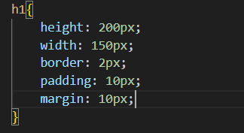

**5. What do you understand by CSS opacity?**

Ans- In CSS, Opacity refers to the level of transparency of an element. It controls how much content behind the element is visible. Here’s a breakdown of what CSS opacity does.

• Transparency Levels: Opacity is defined by a value between 0 and 1.

~ 0 indicates completely transparent (invisible)

~ 1 signifies fully opaque (completely solid)

~ values between 0 and 1 create partial transparency

**• Applicability:** Opacity applies to the entire element, including its content. So, If you set an element’s opacity to 0.5, both the element and its text/images will be 50% see-through.

**• Inheritance:** Opacity is not inherited by child elements. This means that if you set an opacity on a parent element, its child elements will not inherit that opacity and can have their own opacity styles applied.

**• Fading Effects:** Create hover effects where an element becomes more or less transparent on hover.

**• Overlays:** Create semi-transparent overlays on top of content for modal windows or notifications.

**• Subtle Design Elements:** Add subtle translucent backgrounds or borders for visual interest.

Remember that using opacity on elements with a lot of child elements can make the content difficult to read if the opacity is too low. In such cases, consider using RGBA colors with an alpha channel to set transparency for the background instead.

**Example:**

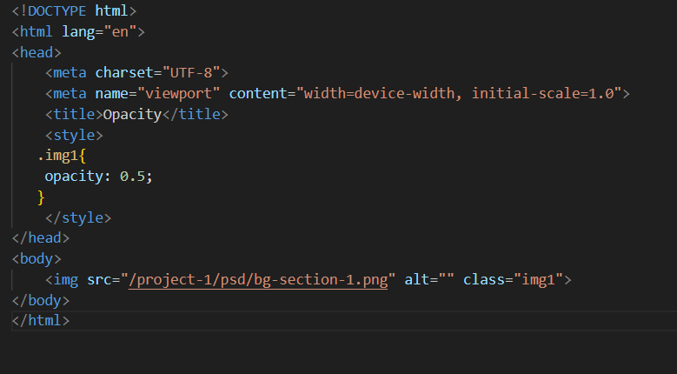

**Output:**

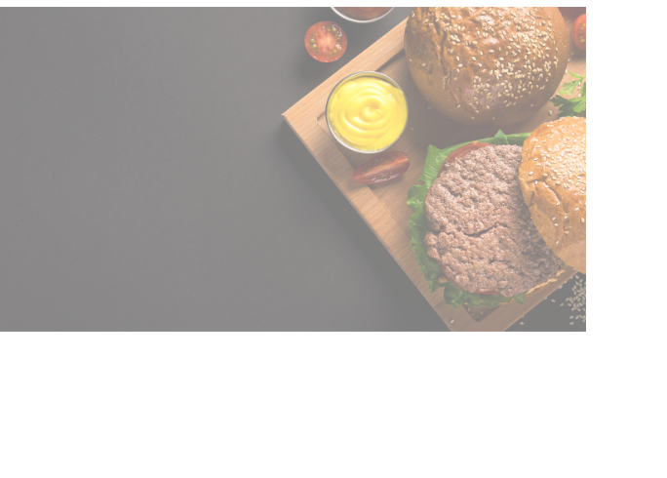

**6. How can the background color of an element be changed?**

Ans- We can change the background color of an element in CSS using the background-color property

**Syntax:**

**CSS**

Selector {

Background-color: color-value;

}

**~ Selector:** This specifies the element you want to target. You can use different selectors like HTML element names ( h1 , p , div), classes, or IDs.

**~ Color-value:** This defines the color you want for the background. you can specify the color in serval ways:

**~ Color names:** Basic color names like red , blue , green , etc.

**~ Hexadecimal codes:** Six-digit codes preceded by a hash symbol # (e.g., #ff0000 for red, #00ffff for cyan).

**~ RGB Values:** Specify the amount of red, green, and blue components in the color (e.g., rgb (255, 0, 0)for red).

**~ RGBA values:** Similar to RGB, but with an additional alpha channel for transparency (e.g., rgba(255, 0, 0) for red with 50% opacity).

~ The background-color property only affects the background behind the element’s content. The element’s text or image will remain unaffected by the background color.

**Example:**

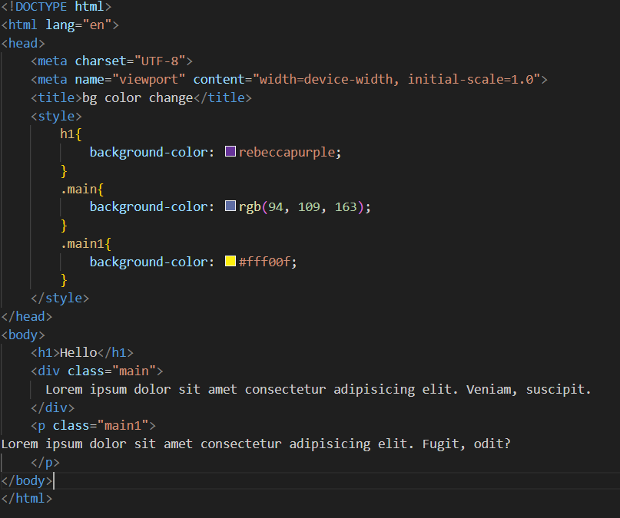

**Output:**

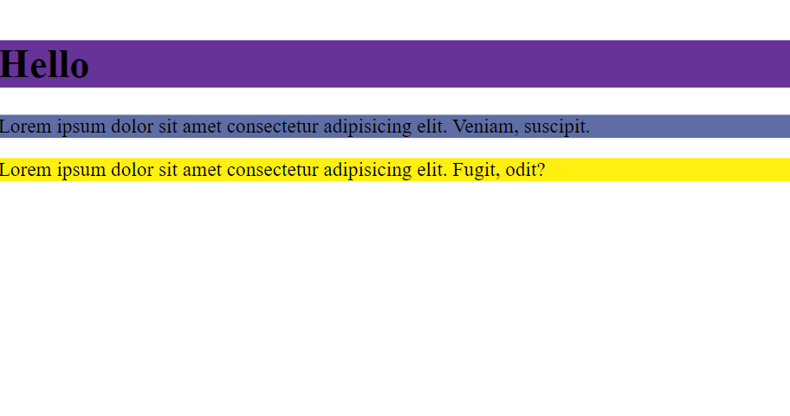

**7. How can image repetition of the backup be controlled?**

Ans- The term “backup” might be a misunderstanding in the context of CSS and image repetition. It’s likely referring to a background image on a web page element.

Here’s how you can control the repetition of a background image in CSS:

Using the background-repeat Property:

The background-repeat property in CSS dictates how a background image is repeated within the element’s background areas. Here are the available options:

**~ repeat (default):** Repeats the image both horizontally and vertically until the entire background area is filled.

**~ repeat-x :** Repeats the image only horizontally across the element’s width.

**~ repeat-y :** Repeats the image only vertically across the element’s height.

**~ no-repeat :** Displays the image only once at it’s original position (top-left corner by default).

**~ space :** Repeats the image with spaces in between, similar to repeat, but the spaces are sized to make the images fit exactly without any overflow.

**~ round :** Repeats the image with some parts potentially cut off to fill the entire background area.

**•** you can combine the **background-repeat** property with other background properties like **background-position** to control the image’s placement within the element.

**Example:**

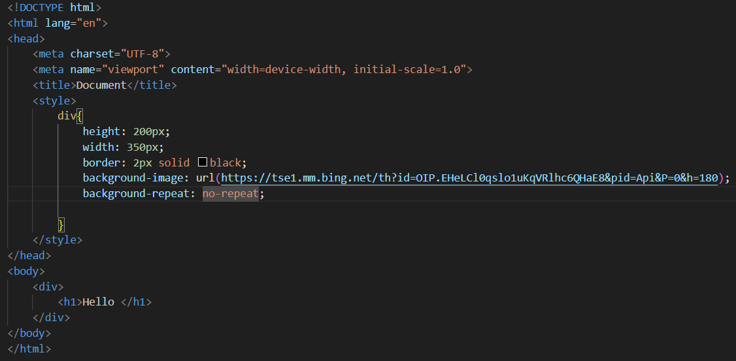

**Output:**

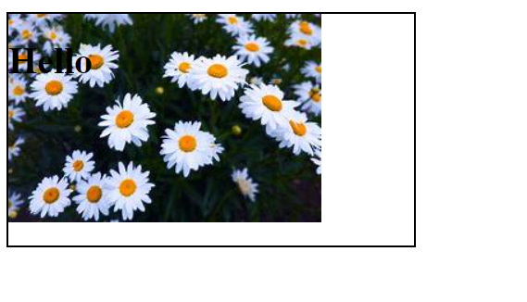

**8. What is the use of the background-position property?**

Ans- The background-position property in CSS controls the initial placement of a background image within its container element.

Here are some key points about background-position :

**• Positioning:** By default, background images start at the top-left corner of their container element. Background-position allows you to move the image around relative to this default position.

**• Values:** It accepts various value to specify the new position. These value can be:

**~** Keywords: Simple terms like top, center , bottom , left and right to position the image at those specific edges.

**~** Length or percentages: Specify an offset from the edges. Pixel (px) , ems or percentage (%) are commonly used units. You can define both horizontal and vertical offsets using two values separated by a space.

**~** Combinations: You can combine keywords and lengths/percentages for more precise control.

**• Multiple background images:** If you have multiple background images set for an element, background-position applies to each image in the order they are listed in the CSS declaration.

**Example:**

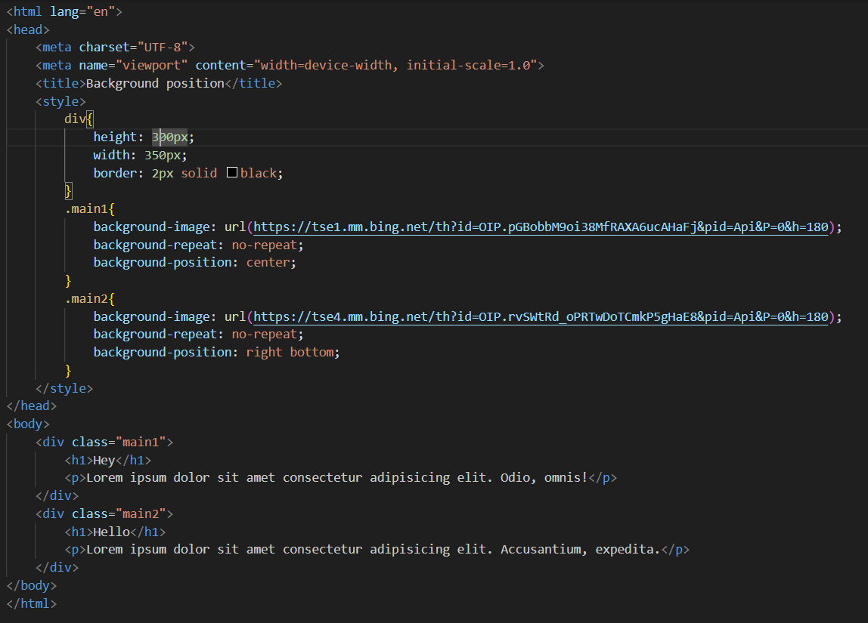

**Output:**

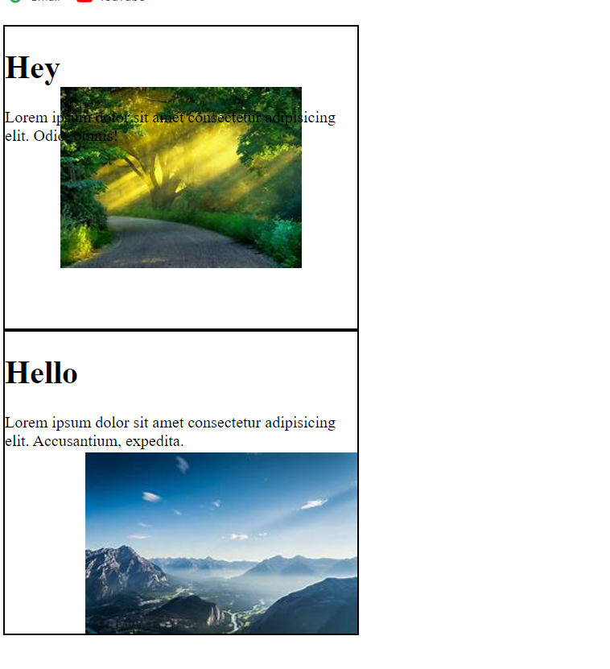

**9. Which property controls the image scroll in the background?**

Ans- The property that controls how a background image scrolls on a webpage is Background-attachment in CSS.

This property determines whether the image stays fixed in position as the content scrolls(fixed) , scrolls along with the content (scroll), or behaves in other specific ways.

**Example:**

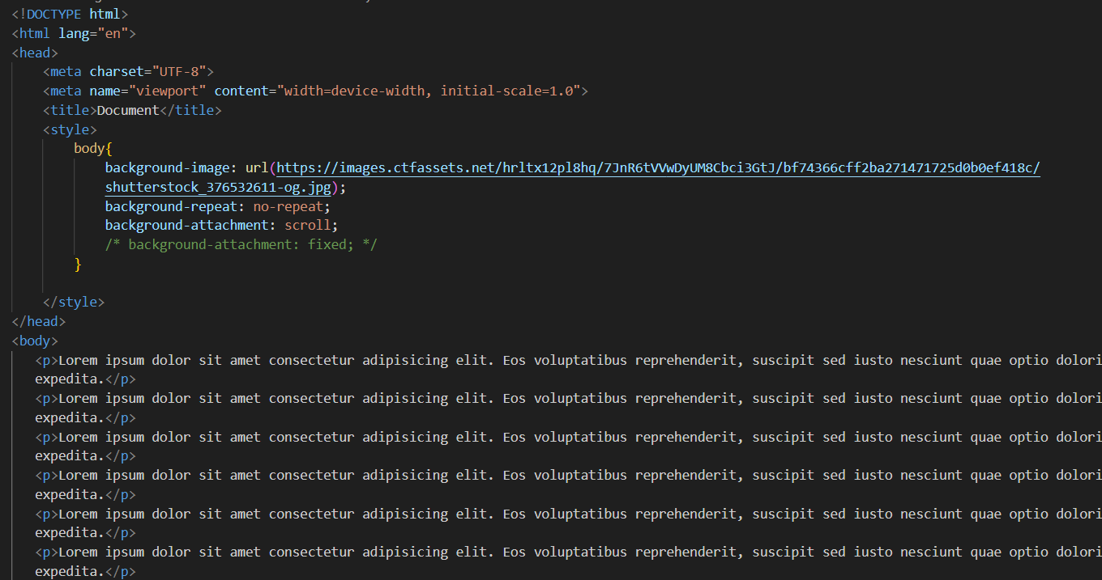

**Output:**

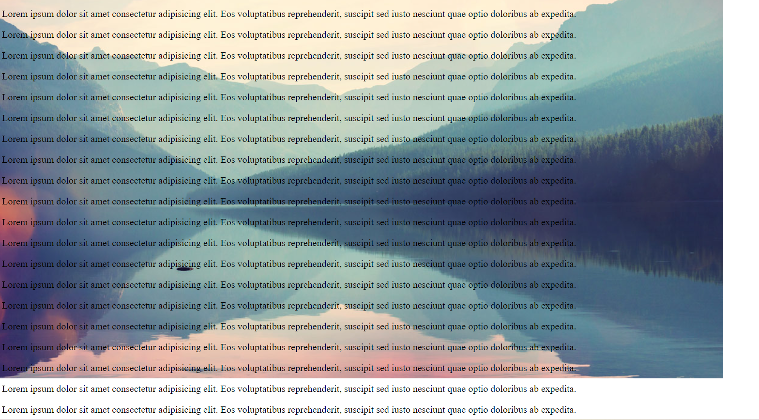

**10. Why should background and color be used as separate properties?**

Ans- Here’s why background and color are separate properties in CSS.

**Increase Readability:** Separating background and color keeps your stylesheets cleaner and easier to understand. Imagine if you had to define a background with an image and a specific color in one property. It would be cluttered and harder to maintain.

1. **Background is more complex:** Background encompasses more than just color. It can include images, gradients, and even multiple layers. Having a separate property allows for more control over these various aspects.
2. **Flexibility:** Using separate properties gives you more flexibility. You can set a background image without necessarily changing the text color of the element, or vice versa.

Even though they are separate, background and color can be combined effectively using the shorthand property **background**. This property allows you to define various background aspects, including color, in the line of code, but it’s still beneficial to understand the underlying separation for better code organization and flexibility.

**Example:**

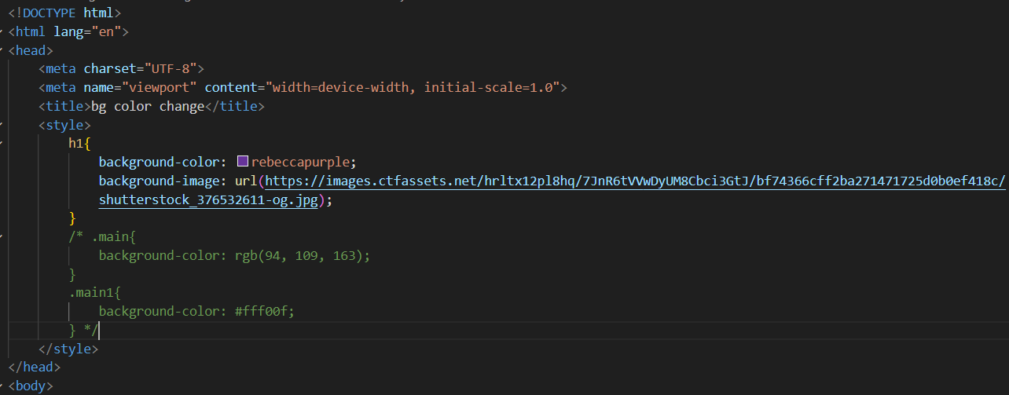

**11. How to center block elements using CSS1?**

Ans- There are two main ways to center a block-level element horizontally:

**1. Using** **margin: 0 auto**

This is the most common and reliable way to center block elements in CSS1.

1. **Set width for the element**: Block element by default take up the full width of their container. To center them horizontally, we need to define a specific width for the element itself.
2. **Set margin: 0 auto** : This sets both the left and the right margins of the element to auto. The auto value tells the browser to automatically calculate the margins needed to center the element horizontally within its container.

**Example:**

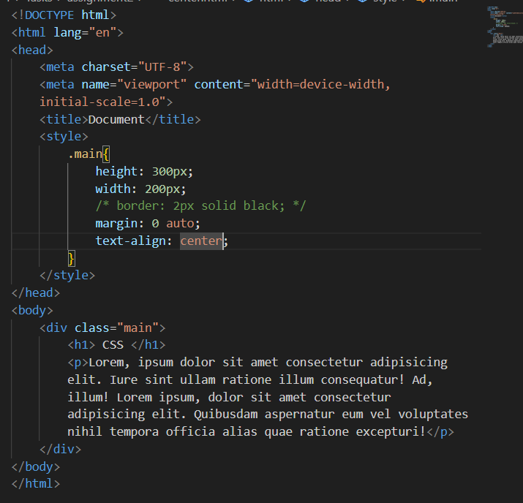

**Output:**

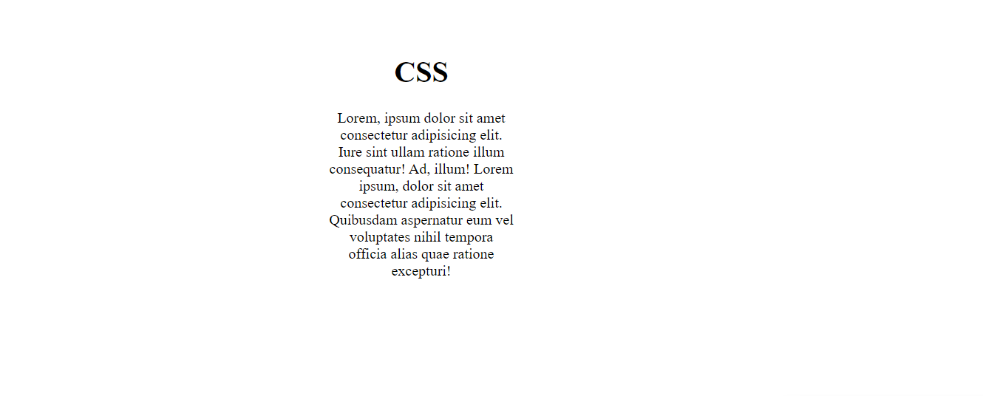**2. Using the <center> tag**

CSS1 introduced the <center> tag, which horizontally centers its content. However, this tag has been deprecated in HTML and should be avoided in moderns web development. It’s generally better to use CSS for layout purposes, as it offers more flexibility and control.

**•** Both methods only center the element horizontally. If you also want to center it vertically, additional CSS properties like text-align: center; for the content within the element.

**Example:**

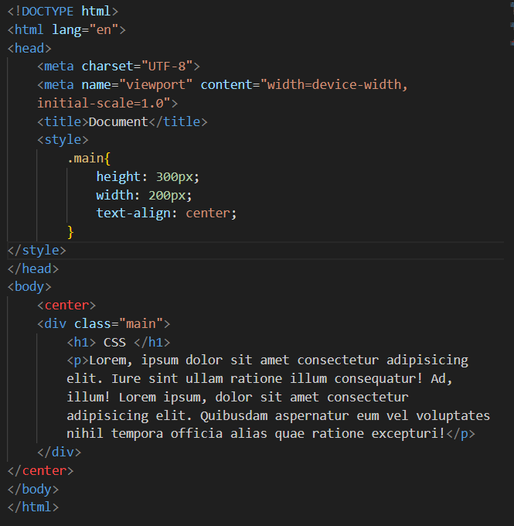

**Output:**

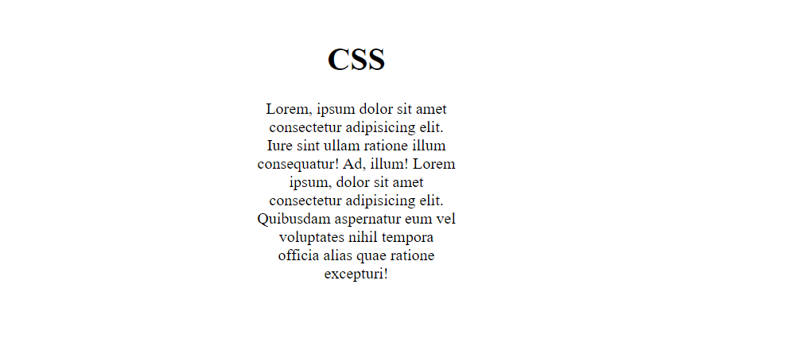

**12. How to maintain the CSS specifications?**

Ans- Maintaining CSS specifications involves a combination of practises to ensure your stylesheets are consistent, up-to-date, and efficient.

**Here are some key strategies:**

1. Use a CSS Preprocessor:

~ Consider using a CSS preprocessor like sass or less. These tools can help you write more maintainable and reusable code with features like variables, mixins, and nesting.

2. Follow a CSS coding style guide:

~ Adopt a consistent coding style for indentation, naming conventions, and property order.

3. Write Modular and Reusable Styles:

~ Instead of duplicating styles for similar elements, create classes with reusable properties.

4. Utilize CSS Specificity Carefully:

~ Specify determines which style applies when multiple rules target the same element.

5. Validate your CSS:

~ Use online tools or browser developer tools to validate your CSS and identify potential errors or syntax issues.

6. Use a Linter or Code Formatter:

~ Tools like linters or code formatters can help automate some aspects of maintaining code quality.

7. Write Clean and Commented Code:

~ Add comments to explain complex logic or non-obvious choices. Clear code is easier to understand and maintain in the long run.

8. Document your Styles:

~ Consider creating external documentation for your stylesheets, especially for larger projects.

9. Test Your Styles Across Browsers:

~ Always test your website in different browsers to ensure consistent rendering and avoid browser-specific styling issues.

By following these practices, you can maintain well-structured, efficient, and future-proof CSS that remains easy to understand and update over time.

**13. What are the ways to integrate CSS as a web page?**

Ans- There are three Primary ways to integrate CSS with an HTML web page:

**1. Inline Styles:**

~ Inline styles are defined directly within an HTML element using the **style** attribute.

~ This method offers fine-grained control over a specific element’s appearance but can lead to cluttered HTML and difficulty maintaining consistency across multiple elements.

**Example:**

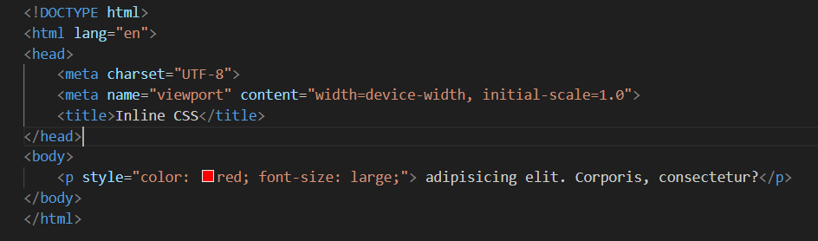

**2. Internal Styles:**

~ Internal styles are defined within the <style> tag placed in the <head> section of your HTML document.

~ This approach allows you to group styles for a single page and keeps your HTML cleaner.

**Example:**

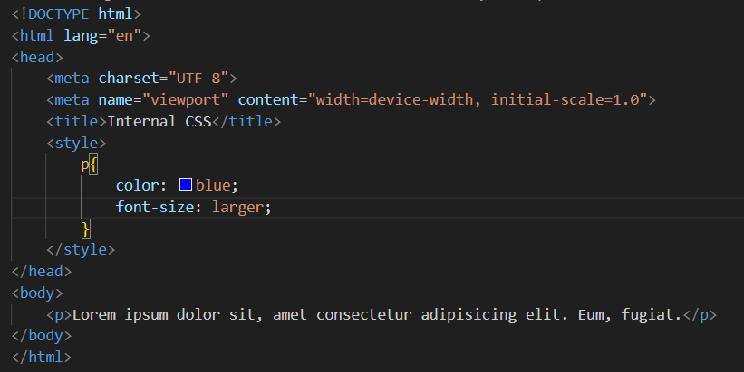

**3. External Styles:**

~ External styles are defined in a separate CSS file linked to the HTML document using the <link> tag in the <head> section.

**Example:**

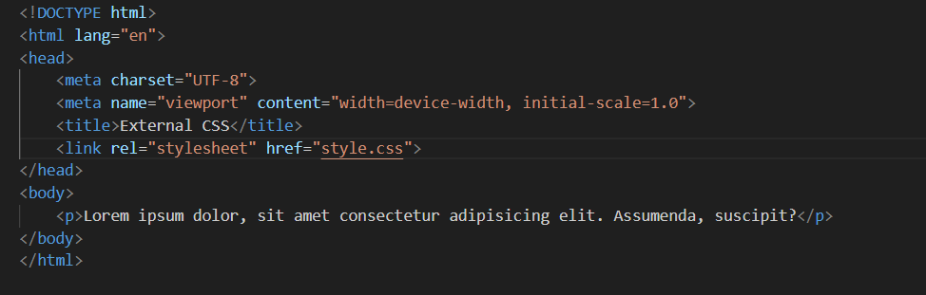

**• Maintainability:** Styles are kept separate from HTML, making them easier to manage and update for multiple webpages.

**• Reusable:** A single CSS file can style numerous HTML pages, promoting consistency across your website.

Choosing the appropriate method depends on the project’s scale and your specific needs. For larger websites with many pages, external styles are the preferred approach due to maintainability and reusability benefits.

**14. What is embedded style sheets?**

Ans- Embedded stylesheets, also known as internal stylesheets, are a way to define CSS styles within your HTML document itself. They are created using the **<style>** tag placed in the **<head>** section of your HTML.

**How it works:**

1. You place the opening **<style>** tag within the <head> section of your HTML document.
2. Inside the **<style>** tags, you write your CSS code, defining styles for elements, classes, or IDs.
3. The closing **</style>** tag marks the end of your CSS styles.

**Example:**

**15. What are the external style sheets?**

Ans- External stylesheets are the preferred method for incorporating CSS into your website. They provide serval advantages over inline and internal stylesheets, making them ideal for maintaining consistency and efficiency across multiple web pages.

**How it works:**

1. **Create a CSS File:** Write your CSS styles in a text editor and save the file with a **.css** extension (e.g., **style.css**).
2. **Link the CSS File:** In your HTML document’s **<head>** section, add a **<link>** tag with the **rel** attribute set to “**stylesheet**” and the **href** attribute pointing to the path of your CSS file.

**Example:**

**HTML File:**

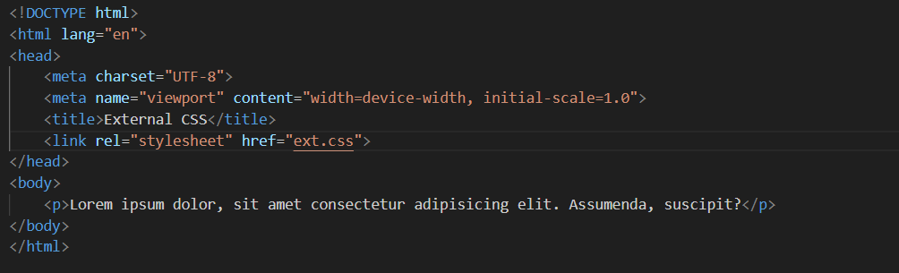

**CSS:**

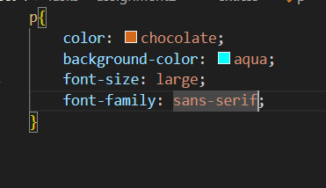

**Output:**

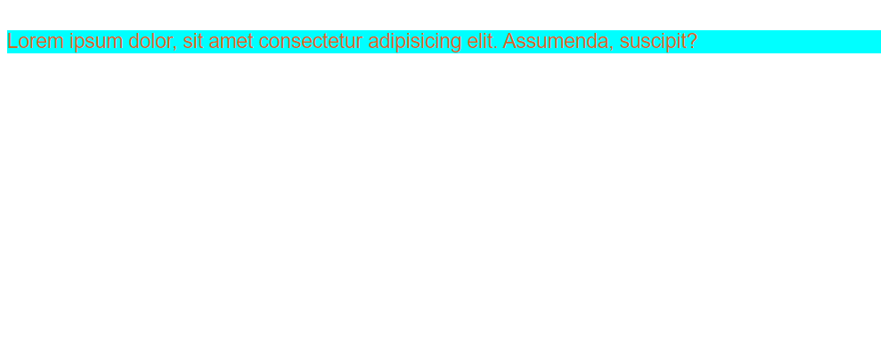

**16. What are the advantages and disadvantages of using external style sheets?**

Ans-  **Advantages of External Style Sheets:**

**~ Maintainability:** Styles are kept separate from HTML, allowing you to modify them in one central location, impacting all linked web pages. This reduces redundancy and simplifies updates.

**~ Reusability:** A single CSS file can style numerous HTML pages, ensuring a consistent look and feel throughout your website.

**~ Performance:** Browsers can cache external stylesheets. This means that on subsequent visit to your website, the styles don’t need to be downloaded again, improving loading speed.

**Disadvantages Of External Style Sheets:**

**~ Initial Setup:** Setting up external stylesheets might require slightly more effort initially compared to inline styles. You need to create a separate CSS file and link it to your HTML document.

**~ Debugging Complexity:** If you have a styling issue and forget where the styles are defined, troubleshooting might take a bit longer compared to inline styles where the styles are right next to the element.

Overall. The advantages of external stylesheets far outweigh the disadvantages. For websites with multiple pages or a focus on maintainability and performance, external stylesheets are the recommended approach.

**17. What is the meaning of the CSS selector?**

Ans- A CSS selector is a pattern used to select and target one or more HTML elements for styling. Selectors are a fundamental part of CSS, allowing developers to apply styles selectively to specific element on a webpage.

Selectors can target elements based on various criteria such as element type, class, Id ,attributes, and relationship with other elements in the HTML structure.

**~ Element Selector:** Target specific HTML elements by their tag name 9 h1, p, div)

**~ Class Selector:** Target element with a particular class assigned using a period (**.**) followed by the class name ( **.container** , **.main**)

**~ ID Selector:** Target a unique element using a hash (**#**) symbol followed by the element’s ID (**#main** , **#main1**)

**~ Universal Selector:** Target all elements with an asterisk (**\***).

**~ Descendant Selectors:** Target elements based on their relationship within the HTML structure using spaces or greater than symbols.

**~ Attribute Selectors:** Target elements based on the presence or value of a specific attribute within square brackets ( **[]** ), (e.g., **[href]** )

**~ Pseudo-Classes:** Apply styles based on a specific state or condition (e.g., **:hover** , **:focus**, **:nth-child**).

**~ Pseudo-Elements:** Target specific parts of an element (e.g., **::before** , **::after** ).

**18. What are the media types allowed by CSS?**

Ans- CSS media queries originally included a set of media types that corresponded to the kind of device the content might be displayed on. These media types have been deprecated in favor of media features, which provide a more flexible way to target style based on device capabilities.

Technically Allowed Types:

**~ all:** Applies to all devices (generic and not very useful).

**~ print:** Targets styles for printed documents.

**~ screen:** Targets styles for screen-based devices.

Recommendation: Use media features instead. Media features provide more granular control over how styles are applied based on device capabilities.

**Using Media Queries:**Media types are typically used in conjunction with media queries. Media queries are expressions that check for specific characteristic of the device or environment, such as screen size, orientation, resolution, and more.

**Example:**

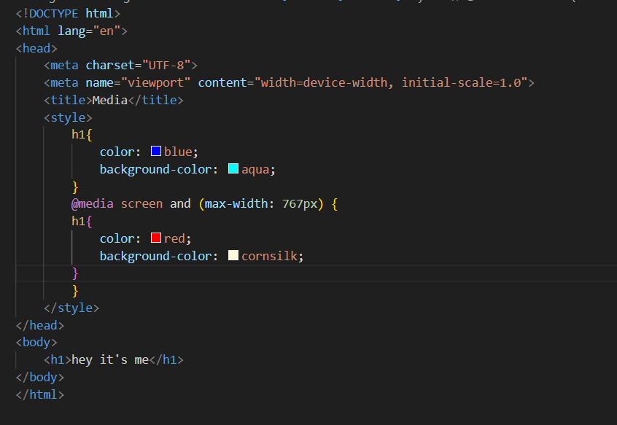

**19. What is the rule set?**

Ans- A rule set in CSS consists of one or more CSS rules that define how HTML elements should be styled.

It consists of two main parts:

1. **Selectors:** This part specifies which HTML elements the rule set applies to. Selectors can target elements by their tag name ( **h1** ), class ( **.container** ), ID ( **#container** ) or combination of these using more complex selectors.

**2. Declaration Block:** This block enclosed in curly braces {} contains one or more declarations that define the styles for the selected elements. Each declaration consists of a property name ( color ) and a value ( red ) separated by a colon : . The declaration block specifies how the selected elements will be displayed, such as their font color, background, size, and more.

**Example:**

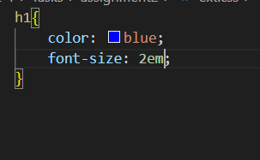

In this example, the **h1** selector targets all **<h1>** elements on the webpage. The declaration block defines that these elements will have their text color set to blue and their font size increased to double the default size.

CSS has a cascading order where styles are applied based on specificity rules. If multiple rules target the same element, the more specific rule takes precedence. You can also use the **!important** rule to override other styles, but it’s generally recommended to avoid overuse for better maintainability.